Think Your Job is Safe for Your Sleep? These Careers Are The Biggest Sleep Disruptors!

**Explore how your job could be impacting your sleep, health, and daily life in ways you never expected.**

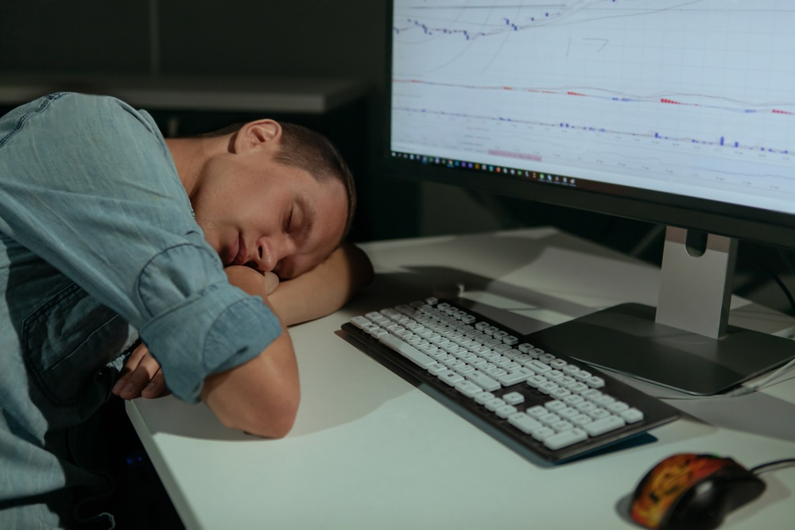

By Abhiram Singireddy

Updated Mon Nov 11, 2024 / 1:23 PM EST

An individual’s sleep can be influenced by numerous aspects of their daily life, including their job responsibilities, stress levels, personal habits, and routines. While long hours and high-stress roles are often blamed for causing exhaustion, could certain jobs carry hidden sleep risks that go beyond these obvious factors? Are the demands of these jobs—whether it’s long shifts, physically demanding tasks, or irregular hours—silently taking a toll on sleep health? To explore this, I analyzed data from a comprehensive sleep, health, and lifestyle dataset on Kaggle, conducting a Bayesian analysis to uncover the significance between one’s occupation and common sleep disorders. This approach allowed me to go beyond surface-level assumptions and examine the nuanced ways different jobs might impact sleep health. Here is what I found:

# Revealed: Nurses Are 19.5 Times More Likely to Suffer from Sleep Apnea

One of the most striking findings was the link between being a nurse and experiencing sleep apnea. By examining the data through a Bayesian lens, I noticed that the **prior odds** of an individual being a nurse was equal to **0.24**. This number represents the baseline likelihood of any individual in the dataset working as a nurse, independent of any sleep disorder diagnosis. Then, I focused specifically on individuals with sleep apnea. Among these, the **true positive rate (TP)**, the probability of being a nurse given a sleep apnea diagnosis surged to **0.78**, indicating that nurses represent a significant portion of those experiencing this condition. On the other hand, the **false positive rate**, the likelihood of being a nurse among those without sleep apnea**,** was only **0.04**. With these values, I computed the **likelihood ratio** to be **19.5**, suggesting that odds of sleep apnea among nurses are 19.5 times higher compared to other professions. This statistic warrants further investigation into working conditions, shift schedules, and other factors that nurses may experience. To expand on my findings, I computed the **posterior odds** by multiplying the likelihood ratio with the prior odds, receiving a value of **4.68**. When this was converted to a **posterior probability,** the likelihood of a nurse having sleep apnea was found to be approximately **82.4%**. This probability suggests that if a person has sleep apnea, there is a 82.4% chance they are a nurse as per the dataset. The high probability also underscores that nurses are increasingly susceptible to this condition.

# Why Accountants Are Losing Sleep: The Alarming Connection to Insomnia

As part of the Bayesian analysis, I examined how likely it is for accountants to suffer from insomnia compared to other occupations. The analysis starts with the **prior odds**, which represent the likelihood of an individual being an accountant. For the dataset, this was calculated at a value of **0.11**. The **true positive rate** was equal to **0.19**, showing that nearly one in five individuals with insomnia are accountants. The **false positive rate,** which measures the likelihood of being an accountant among those who do not suffer from insomnia. This rate was found to be **0.21**, a value slightly higher than the true positive rate.

*The contingency table above provides an overview of the relationship between different occupations and sleep disorders. The rows in the table represent the beliefs (specific occupations including ‘Teacher’, ‘Software Engineer’, etc.). The columns represent the observations (types of sleep disorders such as ‘Insomnia’, ‘Sleep Apnea’).*

The **likelihood ratio** was determined to be **0.91**, suggesting that accountants experience insomnia at a rate consistent with the demands of their profession. The **posterior odds** were calculated by multiplying the likelihood ratio with prior odds and the resulting value was **0.10.** When this was converted to the **posterior probability**, it was determined that likelihood of an accountant experiencing insomnia is approximately **9%**. Insomnia, although present, is not a primary sleep health risk factor for accountants.

|  |  |  |  |
| --- | --- | --- | --- |
|  |  |  |  |

# Putting it All Together

This Bayesian analysis provides valuable insights regarding how certain occupations are connected to specific sleep disorders. The strong association between nursing and sleep apnea highlights the challenges faced by healthcare workers, while the lower likelihood of insomnia among accountants suggests the influence of different stressors. By recognizing these patterns within the data, employers, policymakers, and industry experts can push for effective wellness strategies in the workforce.